**Project Design Phase-II**

**Data Flow Diagram & User Stories**

|  |  |
| --- | --- |
| Date | 14 April 2025 |
| Team ID | 145206 |
| Project Name | Sociopedia |
| Maximum Marks | 4 Marks |

**Data Flow Diagrams:**

A Data Flow Diagram (DFD) is a traditional visual representation of the information flows within a system. A neat and clear DFD can depict the right amount of the system requirement graphically. It shows how data enters and leaves the system, what changes the information, and where data is stored.

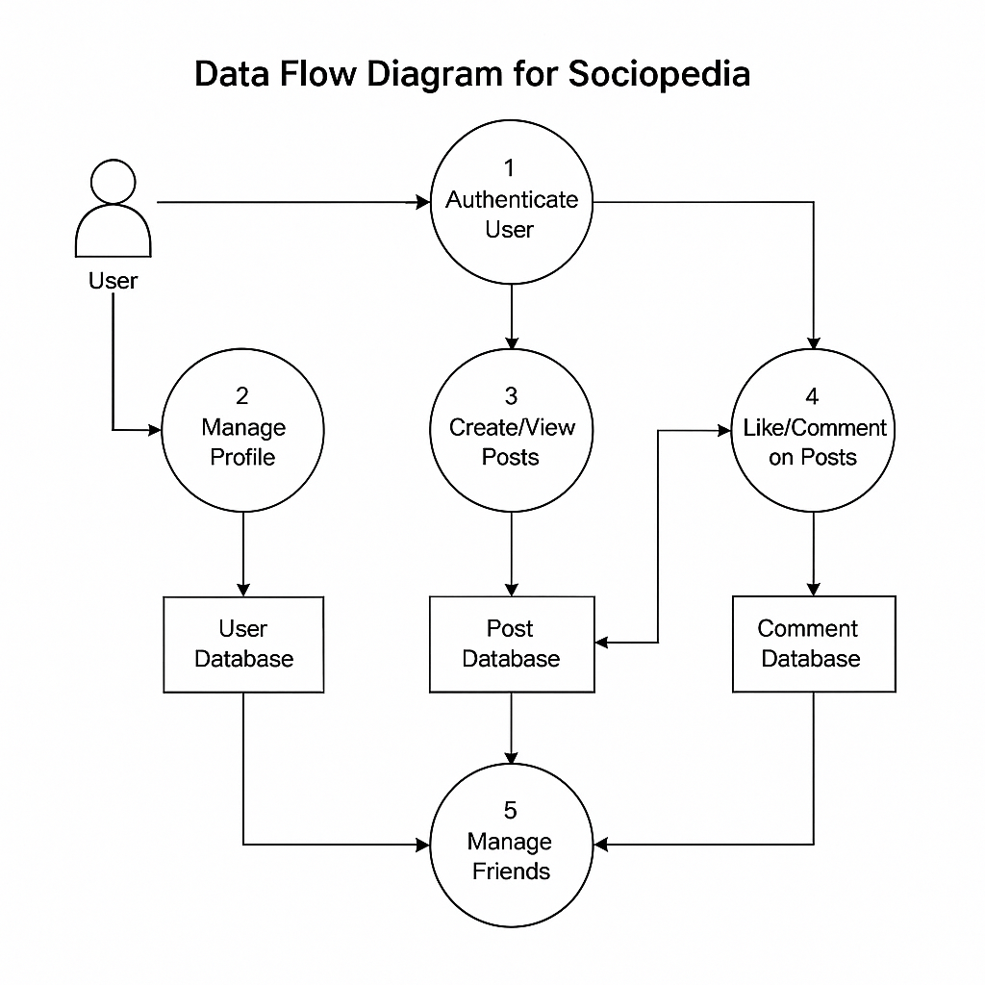

**User Stories**

Use the below template to list all the user stories for the product.

| **User Type** | **Functional Requirement (Epic)** | **User Story Number** | **User Story / Task** | **Acceptance Criteria** | **Priority** | **Release** |
| --- | --- | --- | --- | --- | --- | --- |
| **End User** | Registration | USN-1 | As a user, I can register using email/password. | Account is created; confirmation email sent. | High | Sprint-1 |
|  |  | USN-2 | As a user, I can register/login via Facebook/Gmail. | Dashboard accessible after OAuth. | Medium | Sprint-2 |
|  | Login | USN-3 | As a user, I can log in with email/password. | Redirect to dashboard on success. | High | Sprint-1 |
|  | Profile Management | USN-4 | As a user, I can update my profile picture and bio. | Changes reflect immediately. | Medium | Sprint-2 |
|  | Post Creation | USN-5 | As a user, I can create a post with text/images. | Post appears in my feed and others’ feeds. | High | Sprint-1 |
|  | Notifications | USN-6 | As a user, I receive notifications for likes/comments. | Real-time alerts appear. | Medium | Sprint-3 |
| **Admin** | User Management | USN-7 | As an admin, I can ban users violating guidelines. | User account is deactivated. | High | Sprint-2 |